**MongoDB lab Assignments – Day** 1

MongoDB Exercise in mongo shell

Connect to a running mongo instance, use a database named Mongo Practice. Document all your queries in a JavaScript file to use as a reference.

Insert Documents

Insert the following documents into a movies collection.

Title: fight club, writer: chuck Palahniuko , year:1999, actors: [brad Pitt , Edward Norton].

Title: pulp fiction, writer: Quentin Tarantino, year:1994, actors: [john Travolta, Uma Thurman].

Title: Inglorious Basterds, writer: Quentin Tarantino, year:2009, actors: [brad Pitt, Diane Kruger, Eli Roth].

Title: The hobbit: An unexpected Journey , writer: J.R.R. Tolkein , year: 2012,franchise: the hobbit.

Title: the hobbit: The Desolation of Smaug, writer : J.R.R Tolkein, year: 2013,franchise: the hobbit.

Title: the hobbit: The battle of the five armies, writer: J.R.R Tolkein , year: 2012,franchise: the hobbit.

Title: Pee Wee Hermans Big Adventure.

Title: Avatar.

Query/Find Documents

Query the movies collection to

1. Get all documents

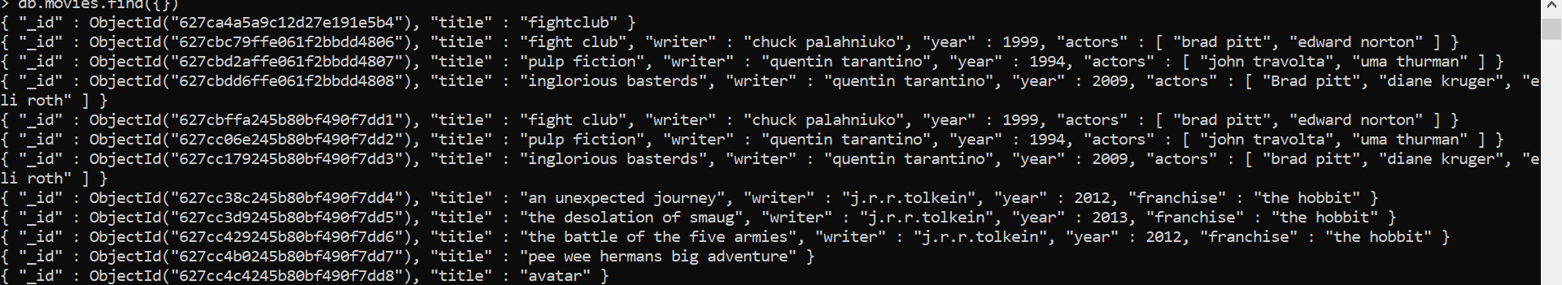

2.Get all documents with writer set to “Quentin Tarantino”.



3.Get all documents where actors include “brad pitt”.



4.Get all documents with Franchise set to “the hobbit”.



5.Get all movies released in the 90’s.



6.Get all movies released before the year 2000 or after 2010.



Update Documents

1.Add a synopsis to “the hobbit: An unexpected journey”: ”A reluctant hobbit, bilbo baggins, sets out to the lonely mountain with a spirited group of dwarves to reclaim their mountain home-and the gold within it – from the dragon smaug”.



2.Add a synopsis to “the hobbit: the Desolation of smaug ”: “The dwarves, along with bilbo baggins and Gandalf the grey, continue their quest to reclaim Erebor, their homeland, from Smaug. Biblo Baggins is in possession of a mysterious and magical ring.” 

3.Add an actor named “Samuel L Jackson” to the movie “Pulp fiction”.



Delete Documents

1.Delete the movie “pee wee Herman’s big adventure”.



2.Delete the movie “Avatar’.



Relationships

1.Find all users.





2.Find all posts.



3.find all posts that was authorized by “GoodGuyGerg”.



4.Find all posts that was authorized by “Scumbag

Steve”.



5.Find all comments.



6.Find all comments that was authorized by “Good Guy Gerg” .



7.Find all comments that was authorized by “Scumbag Steve”.



MongoDB Aggregation Exercises.

Import the zips .json file into your MongoDB. Data Base name is “population” and collection name is “zip codes”.



Population Atlanta

1.use db.zipcodes.find() to filter results to only the results where city is ATLANTA and state is GA.

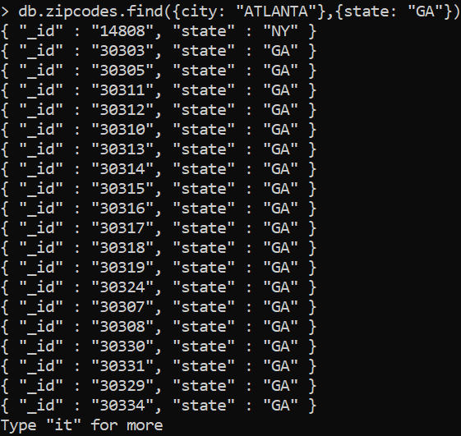

2.use db. zipcodes. aggregate with $match to do the same as above.

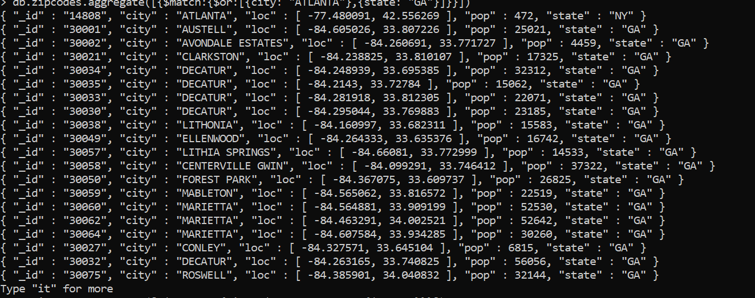

3.use $group to count the number of zipcodes in Atlanta.



4.use $group to find the total population in Atlanta.



Population By State.

1.use aggregate to calculate the total population for each state.

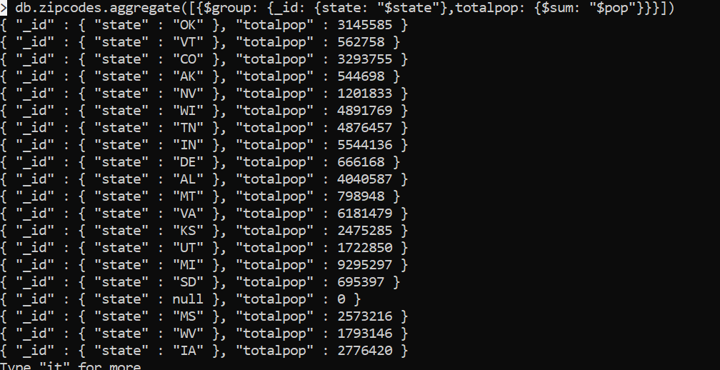

2.Sort the results by population, highest first.

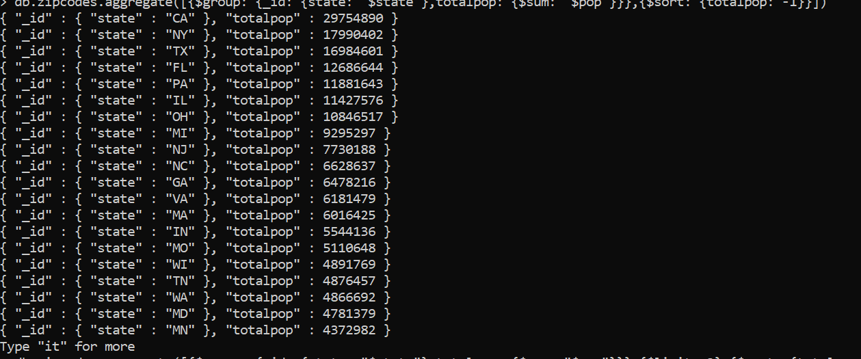

3.limit the results to just the first 3 results. What are the top 3 states in population.



Population by City

1.Use aggregate to calculate the total population for each city. You can use a combination for the _id of the $group: {city: $city, state: ‘$state’}.

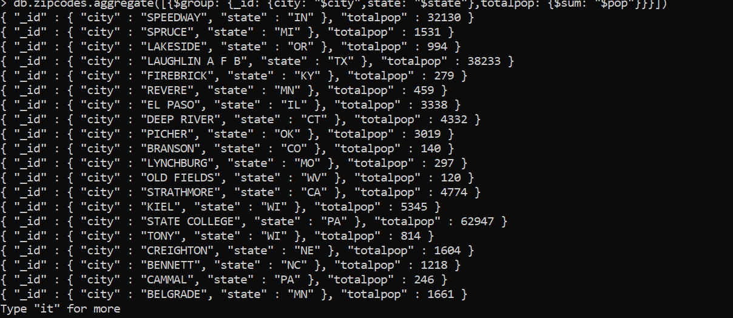

2.Sort the results by population, highest first.



3.What are the top 3 cities in population in Texas.



Bonus

1.Write a query to get the average city population for each state.

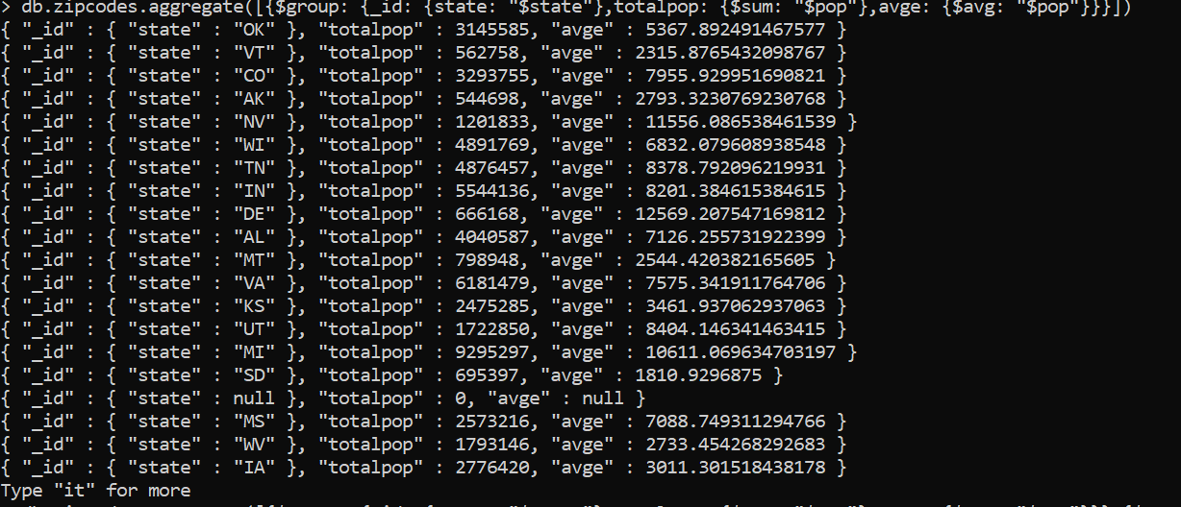

2.What are the top 3 states in terms of average city population.

